**INTRODUCTION TO DBMS**

**Why DBMS:** Human needs have increased tremendously. Now people are

doing much more composite tasks than ever before. The society has become very

complex; a person has to work with huge amount of information every day. In

order to work with the enormous information, we must have a system where we

can store, manipulate and share the information all over the world. It is one of the

core reasons for introducing Database Management Systems (DBMS) as well as

Relational Database Management Systems (RDBMS) now-a-days.

So, one thing is clear to us that we store and manipulate data / information into a

database, where the database contains various types of tables for storing various

types of data / information.

**Data:**

Whatever we are inputting from the keyboard is known as Data. It can also

be called as RAWFACTS / FIGURES

Data never provides any meaning for us

**Information:**

* Processed Data is known as Information
* Information always gives meaning for us

**Database:**

* Collection of information belongs to a particular topic (an organization)
* written in a predetermined manner stored at a particular place so, as per easy retrieval

**DBMS (Data Base Management System):**

* It is a software which is present inside the database, which can maintain and

manage the data within the database

**Types of DBMS:**

1) FMS / FDMS (File Management System /File Management Database System):

* This is first model the released into the market in 1950’s. In this model there

is always arranged in a continue stream of character (or) in a sequential

fashion (or) manner

* The Main disadvantage of this model is whenever we need to retrieve any

data we have to start the searching from the beginning of the file so, it

automatically leads to increases the searching time

2) HMS/HDMS (Hierarchy Management System / Hierarchy Database

Management System):

* This model was developed by IBM in 1960’s, When they developed a

project called IMS (Information Management System)

* In this model data is always arranged in the form of a tree structure in

different levels

* The top level can be called as root. The 2nd , 3rd , 4th Level can be called as parent, child and sibling levels respectively
* The main advantage of this model is we can easily retrieve the value without

wasting much time

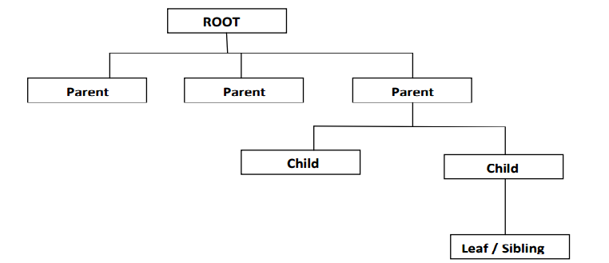

**Drawback:**

* Only one person can share the database simultaneously
* If you want to add the new level in between the existing levels. The user has

to reconstruct the entire tree structure but it is “tedious and time taking process”

**3) NDBS (Network Database Management System):**

* This model was developed by IBM in 1969, when developing a project is

called IMS (Information Management System)

* This model was developed on the basis of an Operating System called

MULTICS (Multiplex Information Computing System)

* The main advantage of this model is more than one person can share the

database concurrently (Simultaneously)

**Disadvantage:**

* There is no proper security for the centralized database
* Redundancy of the database is increased
* It occupies lot of memory and it leads to decrease system performance and

increase the inconsistency

**4) RDMS (Relational Database Management System):**

* This model was developed by a German scientist Mr. EF.CODD in 1970
* Here relation can be defined as commonness between objects these relations

are classified into 3 types

* One to One relation
* One to Many relation / Many to One relation
* Many to Many relation

**One – One relationship:**

* In this relationship one object can have a relationship with another object

student student id

**One - Many relationships:**

* In this relationship one object can have a relationship with many objects

DOT NET

STUDENT JAVA

PHP

**Many – Many relationship:**

* In this relationship many vendors (or) many objects can have the

relationship with many other objects

P1

VENDER1

P2

VENDER2

VENDER3

P3

* All the above relationships can be called as “Degree of Relationships”
* This model was developed on the basis of a mathematical concept can be

called as “Relation Algebra” (i.e. sets & Relations)

**CODD RULES:**

E.F. Codd, the famous mathematician has introduced 12 rules for the relational model for databases commonly known as Codd's rules. The rules mainly define what is required for a DBMS for it to be considered relational,

i.e., an RDBMS.

**The rules are as follows:-**

1. Information Rule

2. Guaranteed Access Rule

3. Systematic treatment of null values

4. Dynamic On-line Catalog Based on the Relational Model

5. Data Sublanguage Rule

6. View Updating Rule

7. High-level Insert, Update, and Delete

8. Physical Data Independence

9. Logical Data Independence

10. Integrity Independence

11. Distribution Independence

12. No subversion Rule

**Properties of RDBMS:**

* In this model data should be stored in the form of tables
* A table can be defined as collection of rows & columns
* The horizontal lines are known as rows/ records / tuples
* The vertical lines are known as columns / fields / Attributes
* The intersection of rows & columns is known as cell
* A cell is a place where we can store our actual data
* The other name of table can be called as “Entity”
* Table should not contain any duplicate columns
* When we define the column in the table user no need to follow any specific order
* When we insert the records into the table user no need to follow any specific order
* Database should not contain duplicate values